***Lab 12-Filter Demo***

*Create a new MVC Application:*

*File > New > Project > Project Name: “Lab 12-FilterDemo” > Empty > OK*

*Add a HomeController*

*Right click on Controller Folder > Add > Controller > HomeController > OK*

*Now add the following two action methods in the HomeController:*

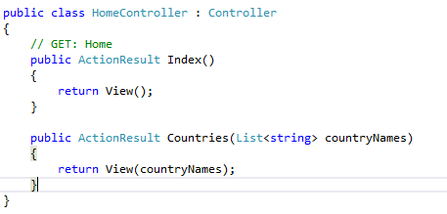

*Right click on Countries action method > Add View > Select Empty View and click on Add. Add the following code:*

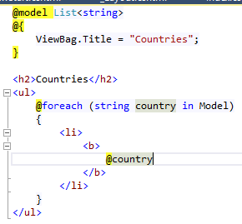

*Right click on Index action method > Add View > Select Empty View and click on Add. Add the following code:*

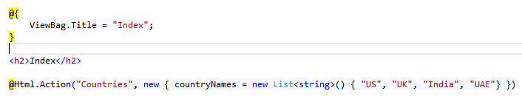

*Now let’s execute the code.*

*Enter the following URL:*

**

*Output will be as follows:*

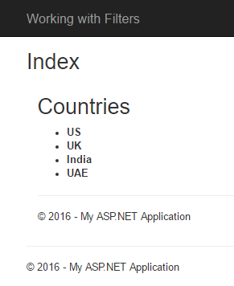

*Enter the following URL:*

**

*It will throw the following error:*

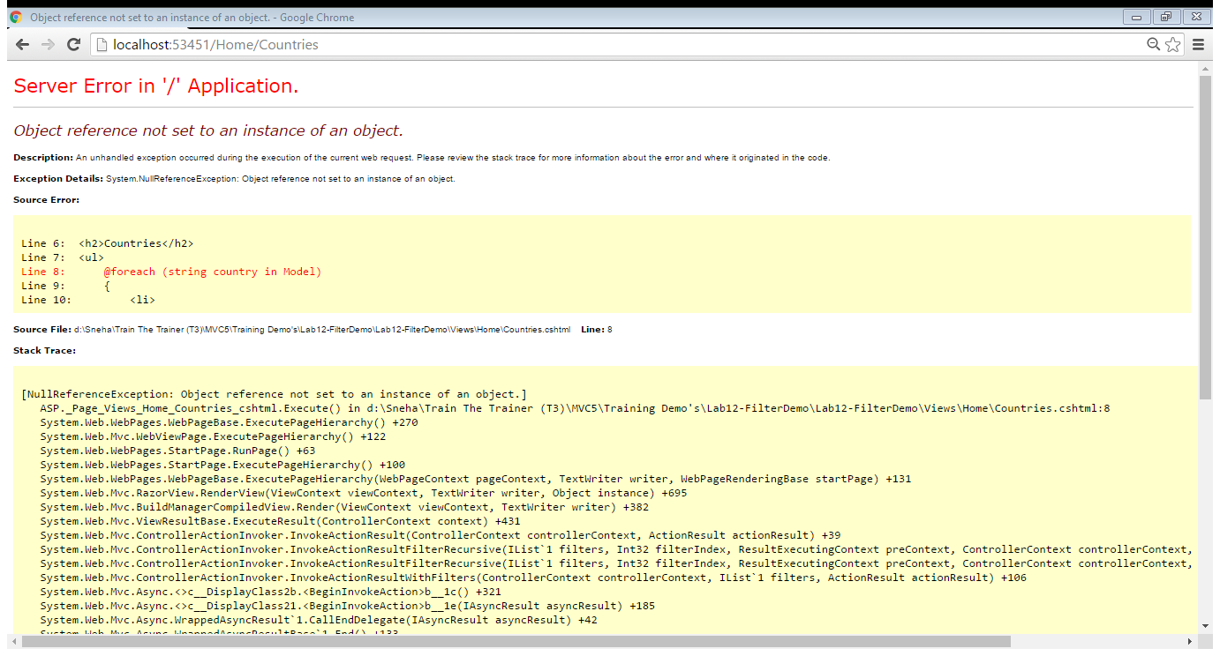

***Now we need to perform two tasks:***

1. ***Countries action method should not be invoked using URL Request.***
2. ***Error Page should be displayed instead of error***

*1st Task of Should not invoke Countries URL Request can be done in 1 step:*

*Add [ChildActionOnly] attribute above Countries action method:*

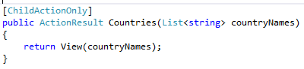

*Now when we execute the URL, we get following error:*

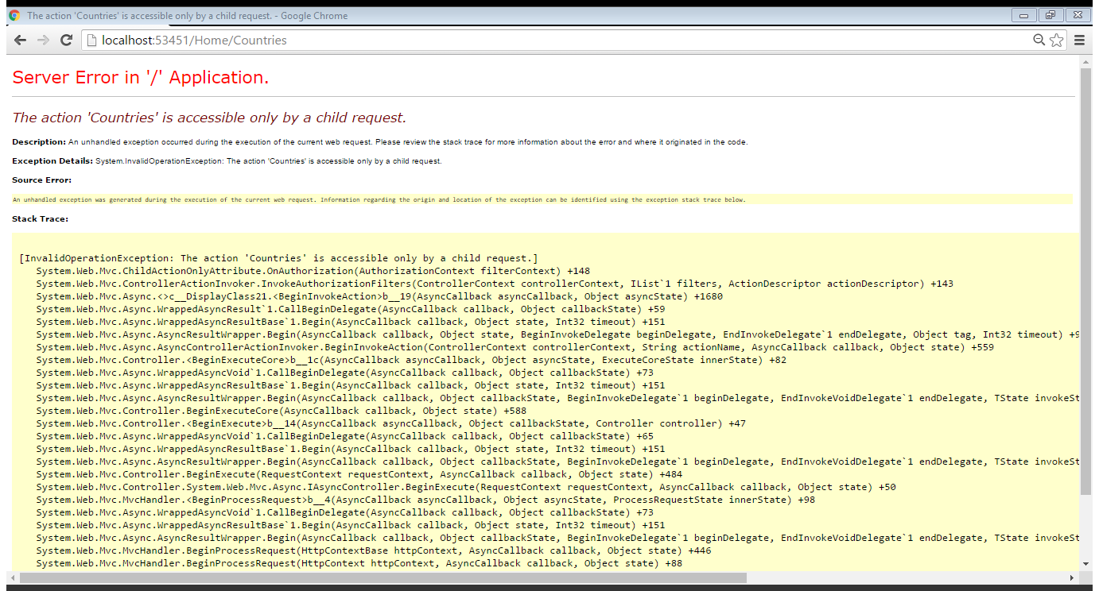

*2nd Task of Error Handling can be done is 3 steps:*

*Step 1: Right click on Shared folder > Add > View > Name it as Error.cshtml > write the following*

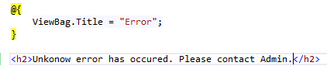

*Step 2: In the web.config add the following code:*

**

*Step 3: Add [HandleError] attribute above the Countries action method:*

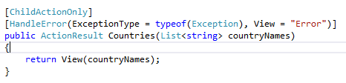

*Now suppose we try to access the following URL:*

**

*We get following Error:*

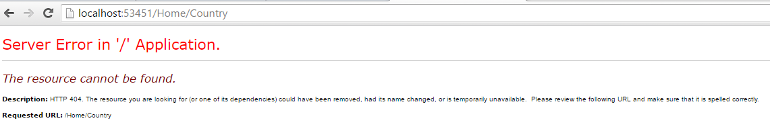

*We want to show a user friendly error. We need to perform 3 steps:*

*Step 1: Add a Not found View in Shared folder – Right click on Shared Folder > Add > View > name it NotFound.cshtml > Empty View > Add*

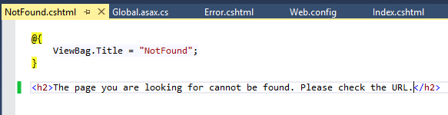

*Step 2: Add a ErrorController – Right click on Controller folder > Add > Controller >Empty Controller> Add > name it ErrorController.cs > Add*

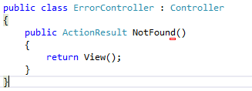

*Step 3: Make necessary modification in web.config*

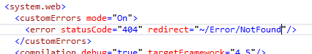

*Now try to access the following URL:*

**

*The following will be output:*

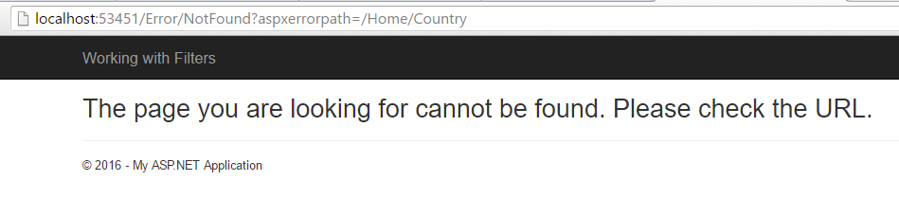

*Now we need to work on caching of data, this help in improving performance:*

*We need to perform 2 steps to work with caching of data:*

*Step 1: Make the following modification in HomeController*

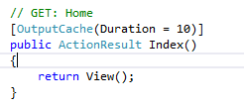

*Step 2: Make the following modification in Index.cshtml*

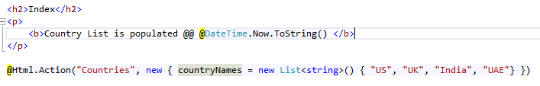

*This will cache the data for 10 seconds. Now if we wish to cache partial data then we need to use [ChildActionOnly] attribute.*

*Following will be the steps:*

*Step 1: Make the following modification in HomeController*

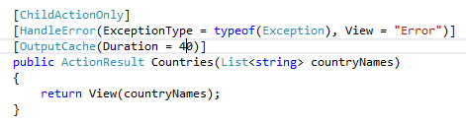

*Step 2: Make the following modification in Countries.cshtml*

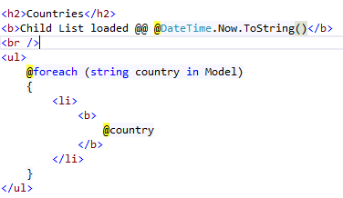

*Cache Profiles:*

*If we use OutputCache attribute multiple times, we end up with duplicated code. Therefore we shall implement CacheProfile. Following are the steps:*

*Step 1: Make the following modificication in web.cofig*

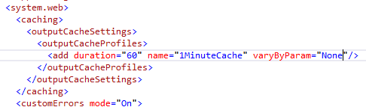

*Step 2: Make the following modification in HomeController*

